1 задание:
#include <windows.h>
#include <tchar.h>
#include <stdio.h>

int _tmain() {
HANDLE hFile;
TCHAR FileName[] = _T("MyFile.txt");
TCHAR TextString[] = _T("Hello, world.");
DWORD iWrite, StringLength = _tcslen(TextString);

_tprintf(_T("There are %ld symbols in text string: %s\n"), StringLength, TextString);

hFile = CreateFile(FileName, GENERIC_WRITE, 0, NULL, CREATE_ALWAYS, FILE_ATTRIBUTE_NORMAL, NULL);
if (hFile == INVALID_HANDLE_VALUE) {
_tprintf(_T("Error creating file. Error code: %d\n"), GetLastError());
return 1;
}

#ifdef UNICODE
iWrite = 2 * StringLength;
#else
iWrite = StringLength;
#endif

WriteFile(hFile, TextString, iWrite * sizeof(TCHAR), &iWrite, NULL);

_tprintf(_T("%d bytes are written to the file\n"), iWrite);

CloseHandle(hFile);

return 0;
}
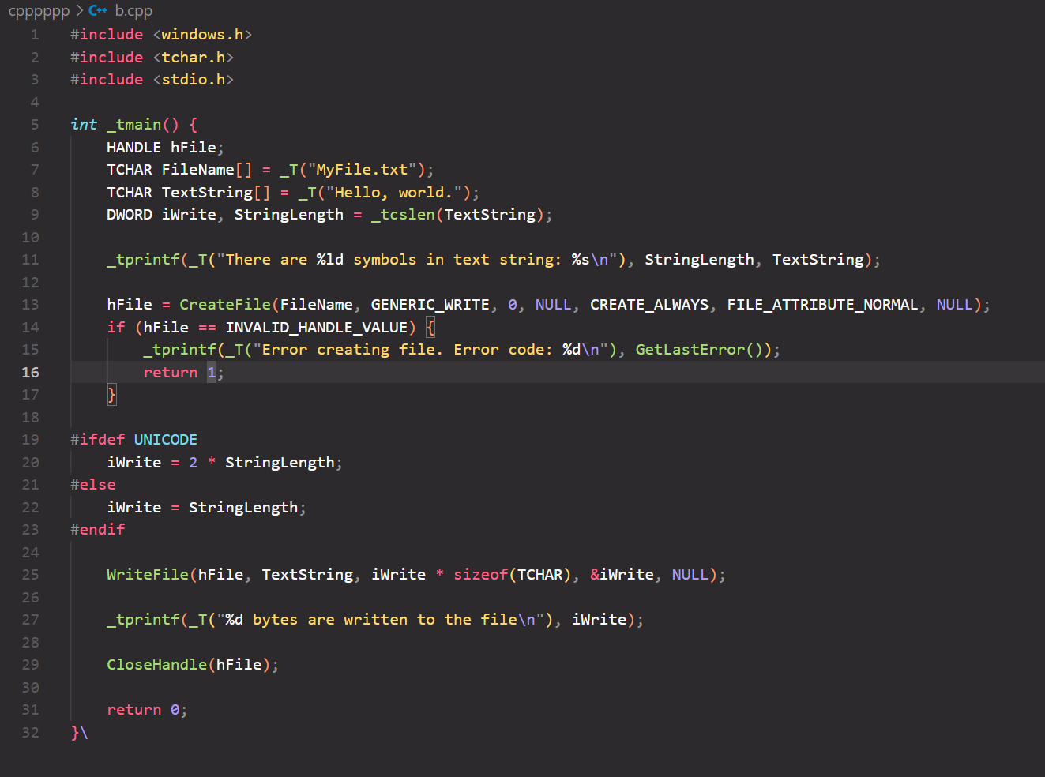
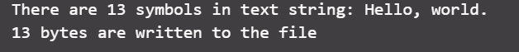
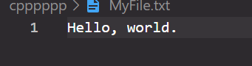

2 задание:
#include <windows.h>
#include <tchar.h>
#include <iostream>

int _tmain() {
HANDLE hFile;
PTCHAR FileName = _T("MyFile.txt");
PTCHAR TextString = _T("Hello, world.");
DWORD iWrite, StringLength = _tcslen(TextString);

_tprintf(_T("There are %ld symbols in text string %s\n"), StringLength, TextString);

hFile = CreateFile(FileName, GENERIC_WRITE, 0, NULL, CREATE_ALWAYS, FILE_ATTRIBUTE_NORMAL, NULL);

iWrite = StringLength * sizeof(TCHAR);

WriteFile(hFile, TextString, iWrite, &iWrite, NULL);

_tprintf(_T("%d bytes are written to file\n"), iWrite / sizeof(TCHAR));

CloseHandle(hFile);

return 0;
}
